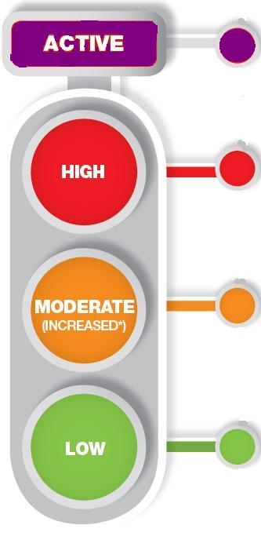

**Emergency admission**

* Septic foot for IV antibiotics – medical admissions
* Critical ischaemia/sepsis for surgery – vascular team

**RD&E foot clinic (rduh.diabetesfootservice@nhs.net or tel 01392 403846) GP referrals only: Direct NHS e-referral service 'diabetic medicine - podiatry and foot - send for triage'**

* Foot ulcers complicated with infection/ischaemia
* Foot ulcer not responding in 2-3 weeks
* Suspected Charcot/unexplained hot red foot
* Severe neuropathic pain
* Footwear assessment for deformity

**Community Podiatry (0345 2667772 or email rduh.podiatryappointments-eastern@nhs.net)**

* Non-infected ulcers
* Ulcers with mild infection (start antibiotics, refer to RD&E foot clinic if not responding in 2-3 weeks)

**Refer to Community Podiatry (details as above)**

* Assessment 1-3 monthly, or according to need (1-2 weeks if immediate concern)

Based on Diabetes UK/NICE NG19 (2016) & Scottish Diabetes Group – Foot Action group 2016

Written June 2012, revised Ocober18

Authors: RD&E diabetic foot clinic and Community Podiatry Team. More info on RDUH Website

**DIABETES FOOTCARE PATHWAY for EXETER, MID & EAST DEVON**

**Primary care annual foot review**

**Foot examination with shoes and socks removed**

• Test sensation using 10g monofilament

• Assess foot pulses (palpate pulses or listen to Doppler sounds)

• Ask about previous ulceration • Inspect for significant callus

• Check for ulceration and deformity • Check footwear

• Identify patients on renal dialysis • Ask about pain

**Only one risk factor present**, e.g.

* Loss of sensation, or peripheral arterial disease, but without callus/deformity

**Previous foot ulceration or amputation or on Renal dialysis**

**Or more than one risk factor** **e.g**.:

* Loss of sensation with callus
* Peripheral arterial disease with deformity

**Ulceration**

**Infection**

**Critical ischaemia or gangrene**

**Unexplained red, hot, swollen foot**

**Suspected Charcot**

**Severe neuropathic pain**

**Refer to Community Podiatry (details as above)**

* Assessment 3-6 monthly, or according to need

**Continue primary care annual review**

* Provide education about foot protection
* Appropriate access to podiatrist if risk identified

**No risk factors present** except callus alone

* Normal sensation
* No sign of peripheral arterial disease
* No other risk factors

**GRADE**